***Project HY360***

Ζαχαρια Περβολαρακης & Στυλιανος Σταματακης

1. **Δημιουργια πινακων**

* CREATE TABLE Employee

(Employee_ID int not null AUTO_INCREMENT,first_name varchar(25) not null,last_name varchar(25) not null,bank_name varchar(25) not null,iban varchar(50) not null UNIQUE,birthday varchar(25) not null,address varchar(25) not null,department varchar(25) not null,phone_number long not null,start_month int not null,start_year int not null,married int not null,working int not null,PRIMARY KEY(Employee_ID))

* CREATE TABLE Permanent_Administrative

(Employee_ID int not null,FOREIGN KEY(Employee_ID) REFERENCES Employee(Employee_ID))

* CREATE TABLE Permanent_Educative

(Employee_ID int not null,FOREIGN KEY(Employee_ID) REFERENCES Employee(Employee_ID))

* CREATE TABLE Contracted_Administrative

(Employee_ID int not null,FOREIGN KEY(Employee_ID) REFERENCES Employee(Employee_ID),end_month int not null,end_year int not null)

* CREATE TABLE Contracted_Educative

(Employee_ID int not null,FOREIGN KEY(Employee_ID) REFERENCES Employee(Employee_ID),end_month int not null,end_year int not null)

* CREATE TABLE Children

(Employee_ID int not null,FOREIGN KEY(Employee_ID) REFERENCES Employee(Employee_ID),age int not null)

* CREATE TABLE Basic_Salary

(Salary_ID int not null AUTO_INCREMENT,amount int not null,PRIMARY KEY(Salary_ID))

* CREATE TABLE Family_Allowance

(Allowance_ID int not null AUTO_INCREMENT,percent int not null,PRIMARY KEY(Allowance_ID))

* CREATE TABLE Research_Allowance

(Allowance_ID int not null AUTO_INCREMENT,bonus int not null,PRIMARY KEY(Allowance_ID))

CREATE TABLE Library_Allowance

(Allowance_ID int not null AUTO_INCREMENT,bonus int not null,PRIMARY KEY(Allowance_ID))

* CREATE TABLE Takes_Salary

(Employee_ID int not null,FOREIGN KEY(Employee_ID) REFERENCES Employee(Employee_ID),Salary_ID int not null,FOREIGN KEY(Salary_ID) REFERENCES Basic_Salary(Salary_ID),month int not null,year int not null)

* CREATE TABLE Takes_Allowance

(Employee_ID int not null,FOREIGN KEY(Employee_ID) REFERENCES Employee(Employee_ID),Family_Allowance_ID int,FOREIGN KEY(Family_Allowance_ID) REFERENCES Family_Allowance(Allowance_ID),Research_Allowance_ID int,FOREIGN KEY(Research_Allowance_ID) REFERENCES Research_Allowance(Allowance_ID),Library_Allowance_ID int,FOREIGN KEY(Library_Allowance_ID) REFERENCES Library_Allowance(Allowance_ID),month int not null,year int not null)

* CREATE TABLE Payments

(Employee_ID int not null,FOREIGN KEY(Employee_ID) REFERENCES Employee(Employee_ID),Salary_ID int not null,FOREIGN KEY(Salary_ID) REFERENCES Basic_Salary(Salary_ID),Family_Allowance_ID int,FOREIGN KEY(Family_Allowance_ID) REFERENCES Family_Allowance(Allowance_ID),Research_Allowance_ID int,FOREIGN KEY(Research_Allowance_ID) REFERENCES Research_Allowance(Allowance_ID),Library_Allowance_ID int,FOREIGN KEY(Library_Allowance_ID) REFERENCES Library_Allowance(Allowance_ID),month int not null,year int not null,total_amount int not null)

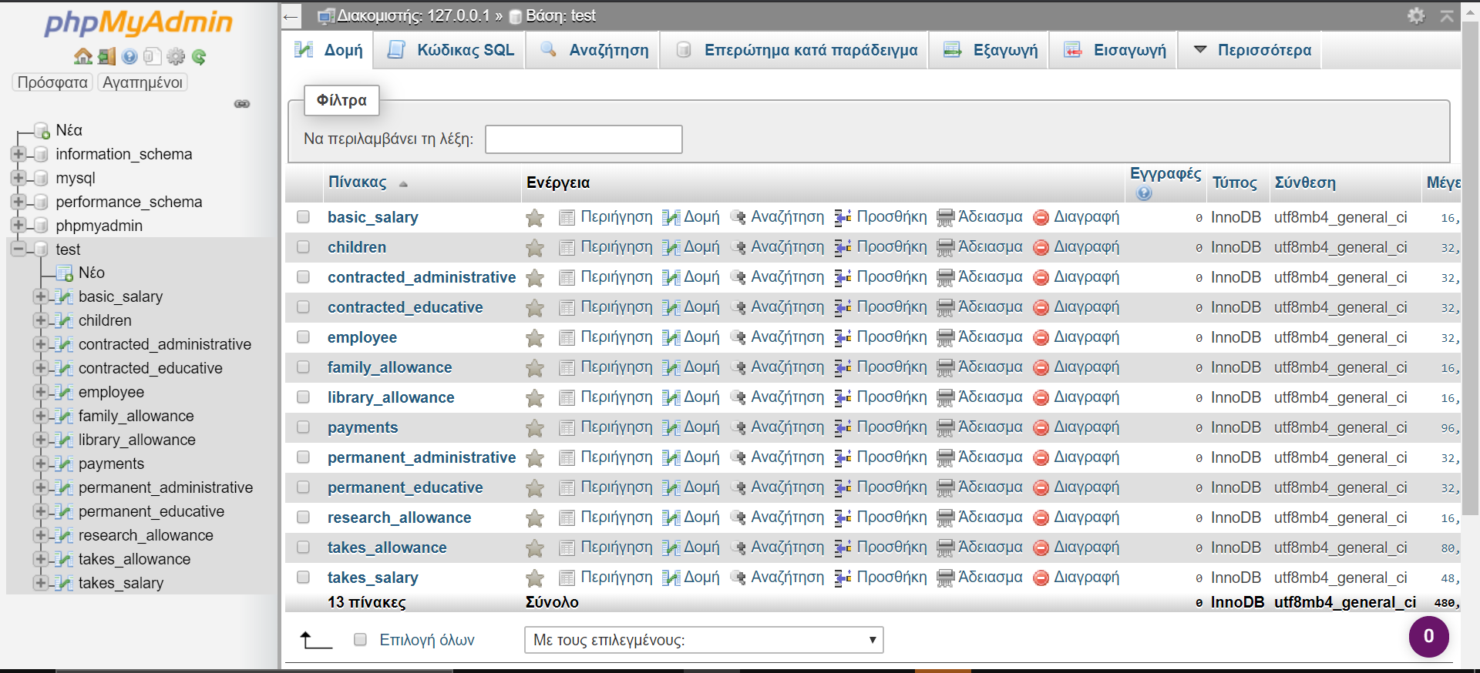

1. **Εισαγωγή βασικών μισθών & επιδομάτων**

* INSERT INTO Basic_Salary (amount) VALUES(1000);
* INSERT INTO Basic_Salary (amount) VALUES(1500);
* INSERT INTO Research_Allowance(bonus) VALUES(500);
* INSERT INTO Library_Allowance(bonus) VALUES(250);

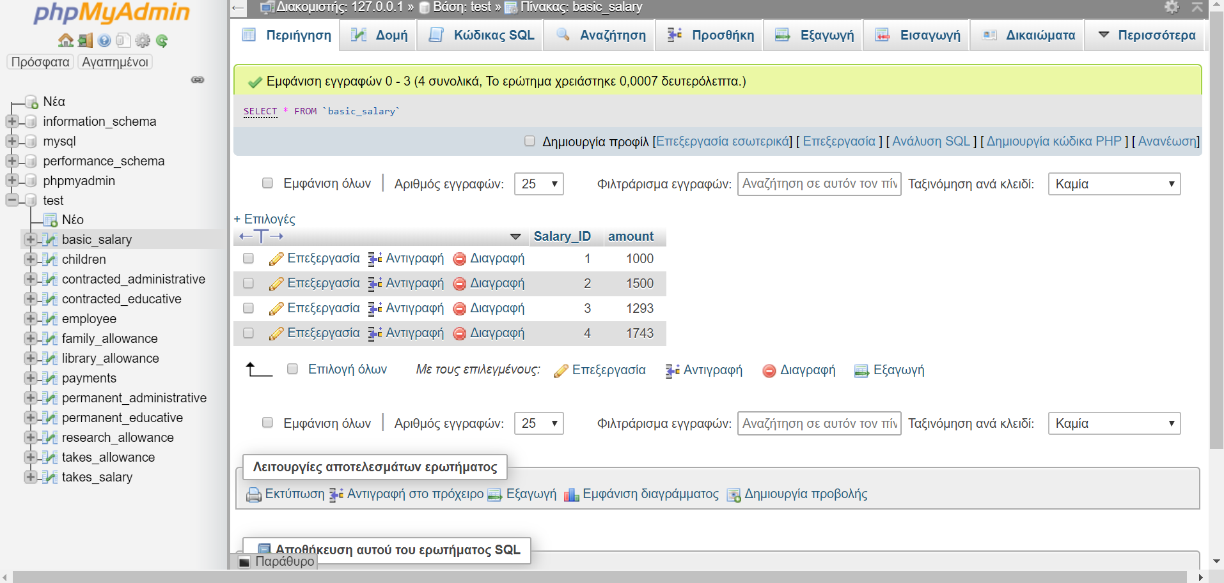

*το Salary_ID (3&4) είναι για τους contracted, οπου θα δουμε μετα, απλα το initialization settαρει τα παντα για τους employee

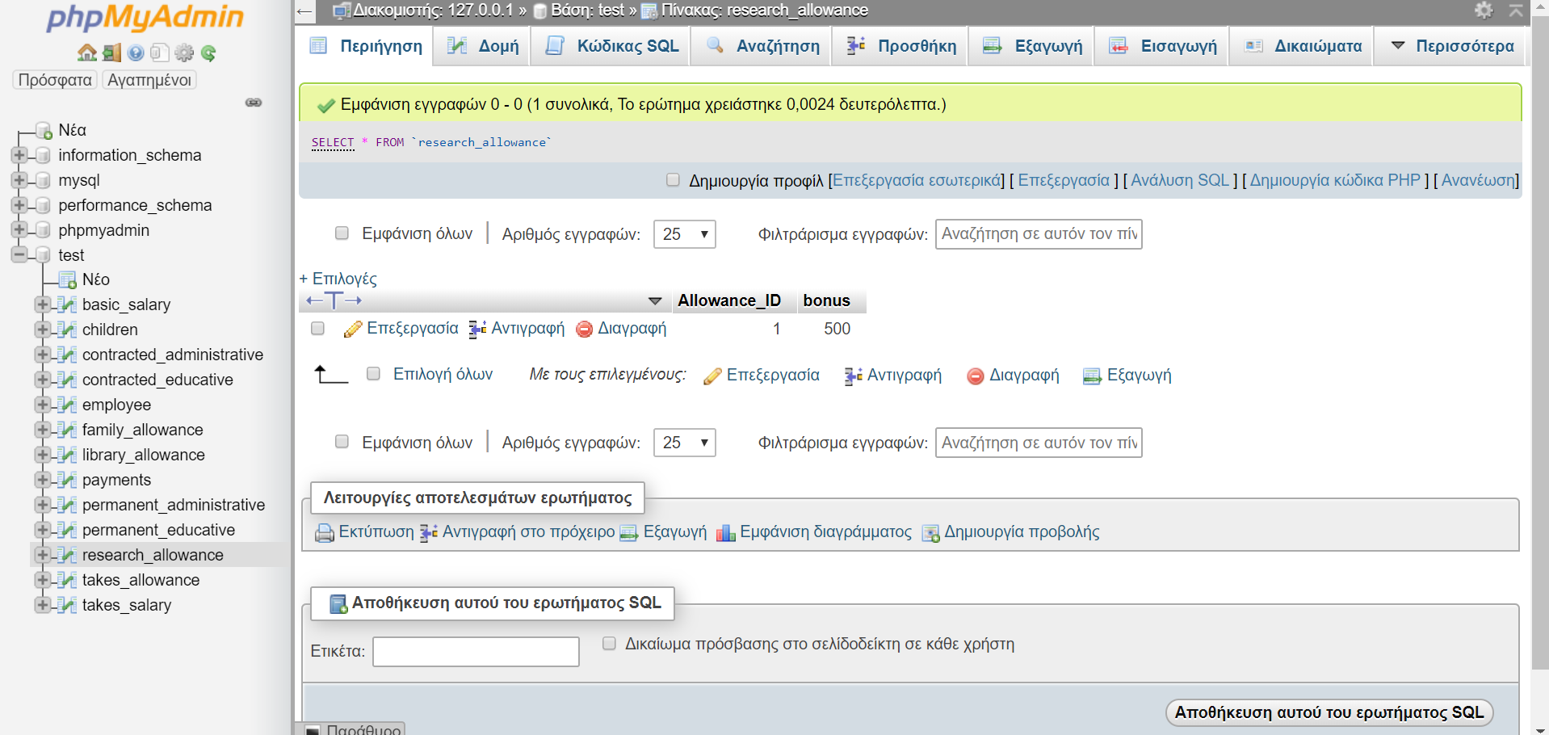

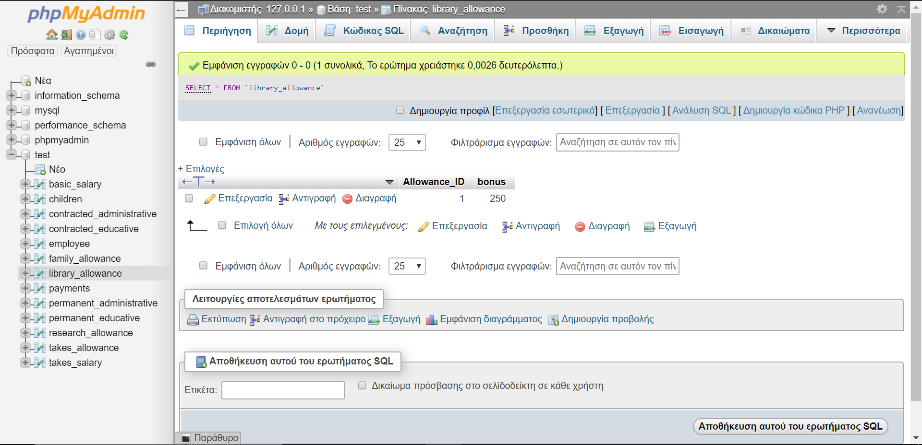

1. **Πρόσληψη υπαλλήλων**

* INSERT INTO employee

(first_name,last_name,bank_name,iban,birthday,address,department,phone_number,start_month,start_year,married,working) VALUES('Manos','Pervolarakis','Ethniki','1694147666','04/10/1995','dipla apo Zack','phs',697488523,0,0,0,1);

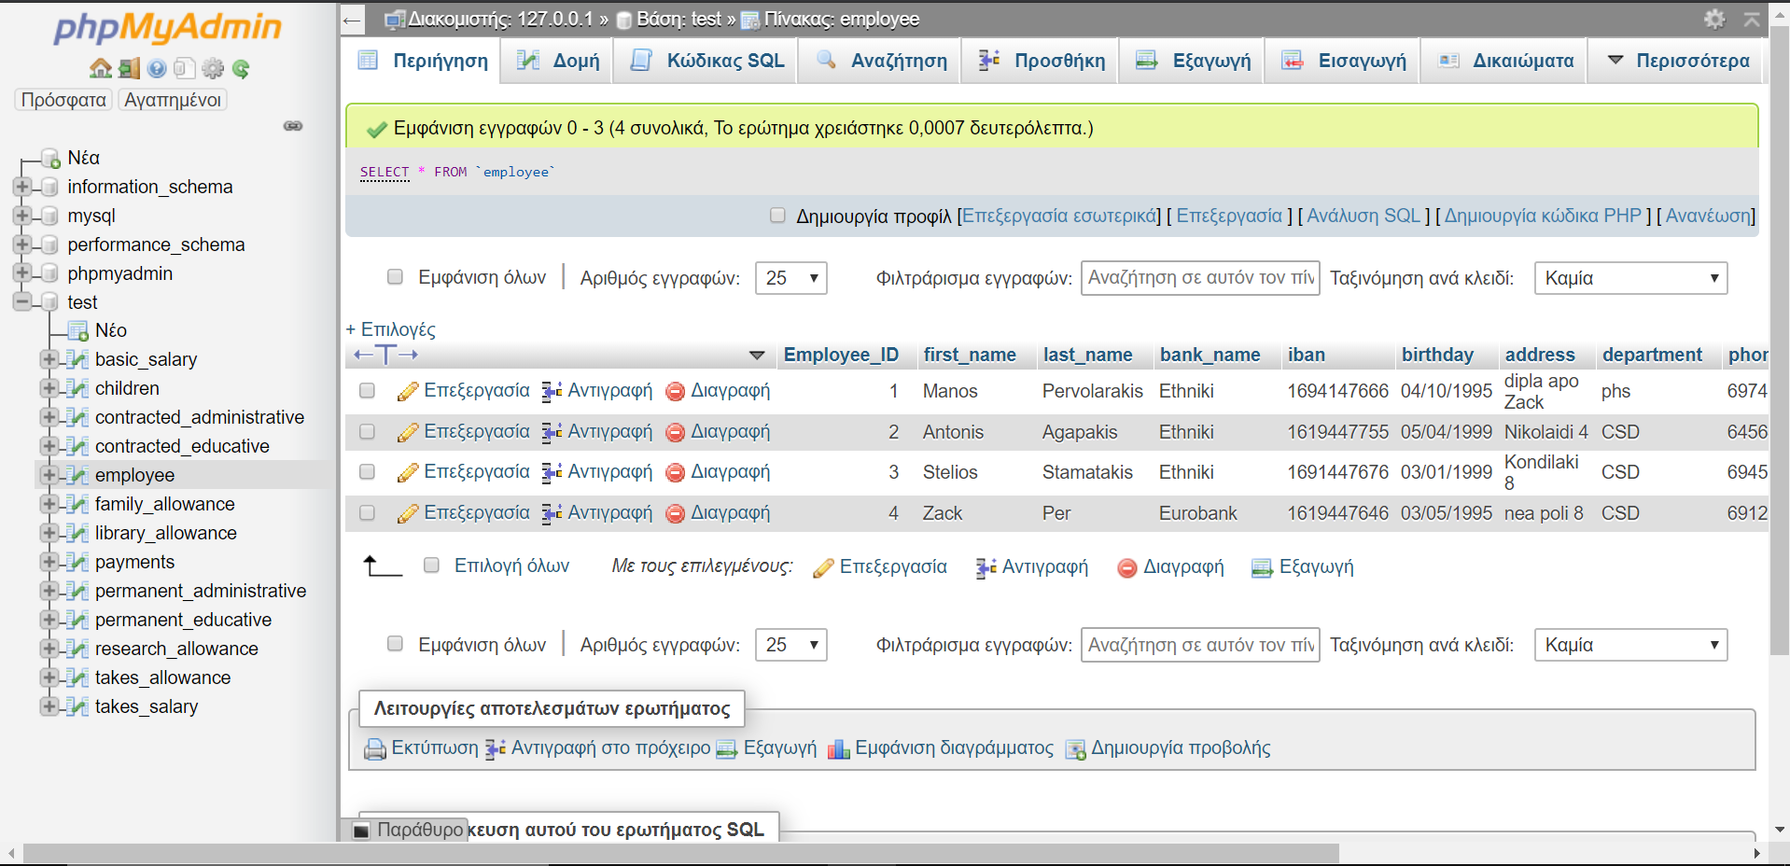

* INSERT INTO permanent_administrative VALUES(1);

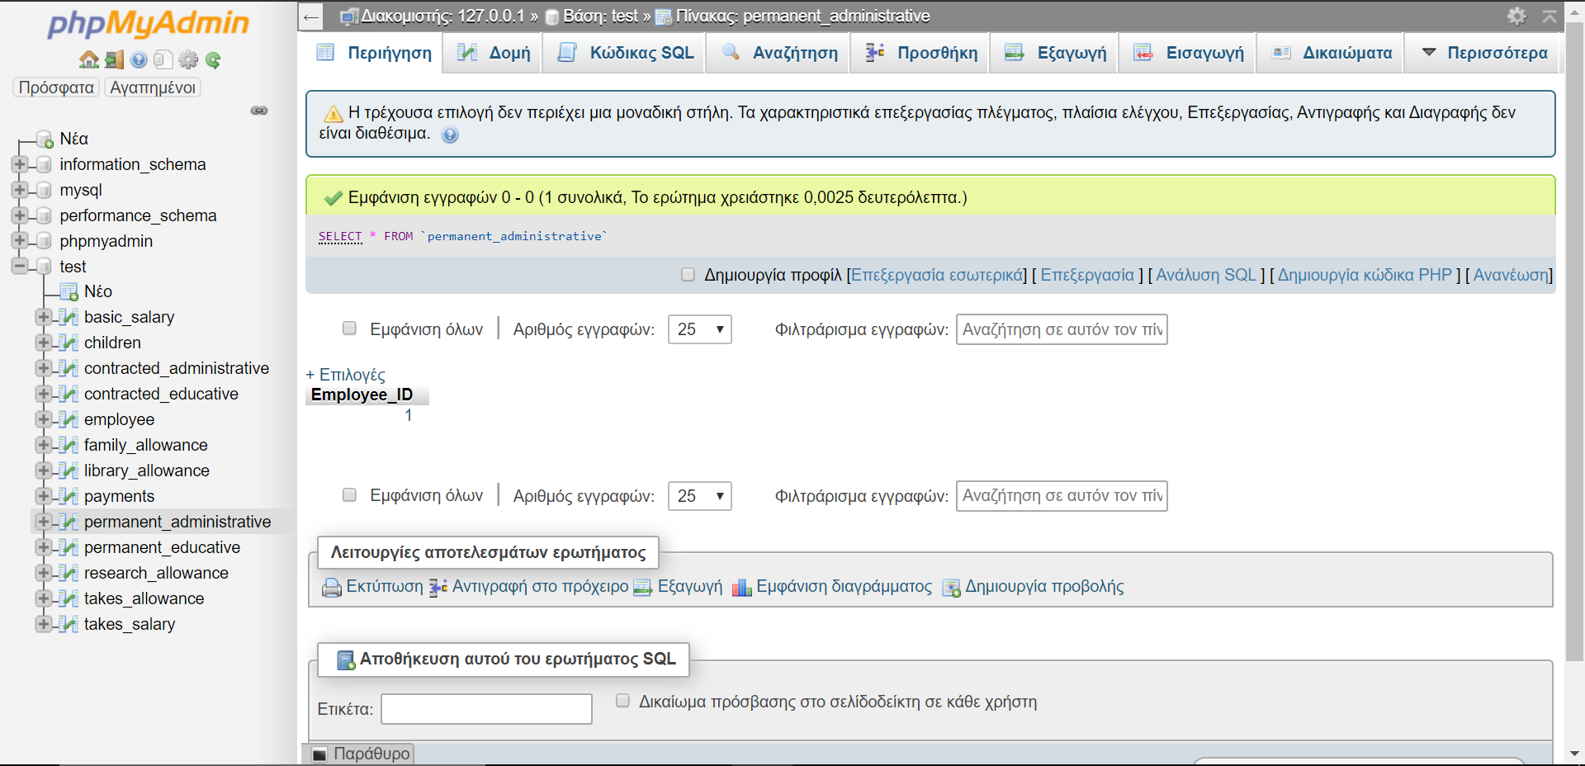

* INSERT INTO Takes_Salary VALUES(1,1,0,2020);

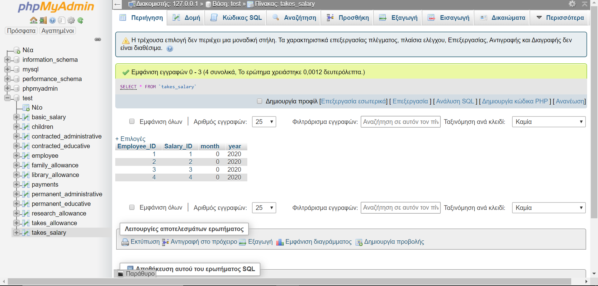

* INSERT INTO Takes_Allowance VALUES(1,NULL,NULL,NULL,0,2020);

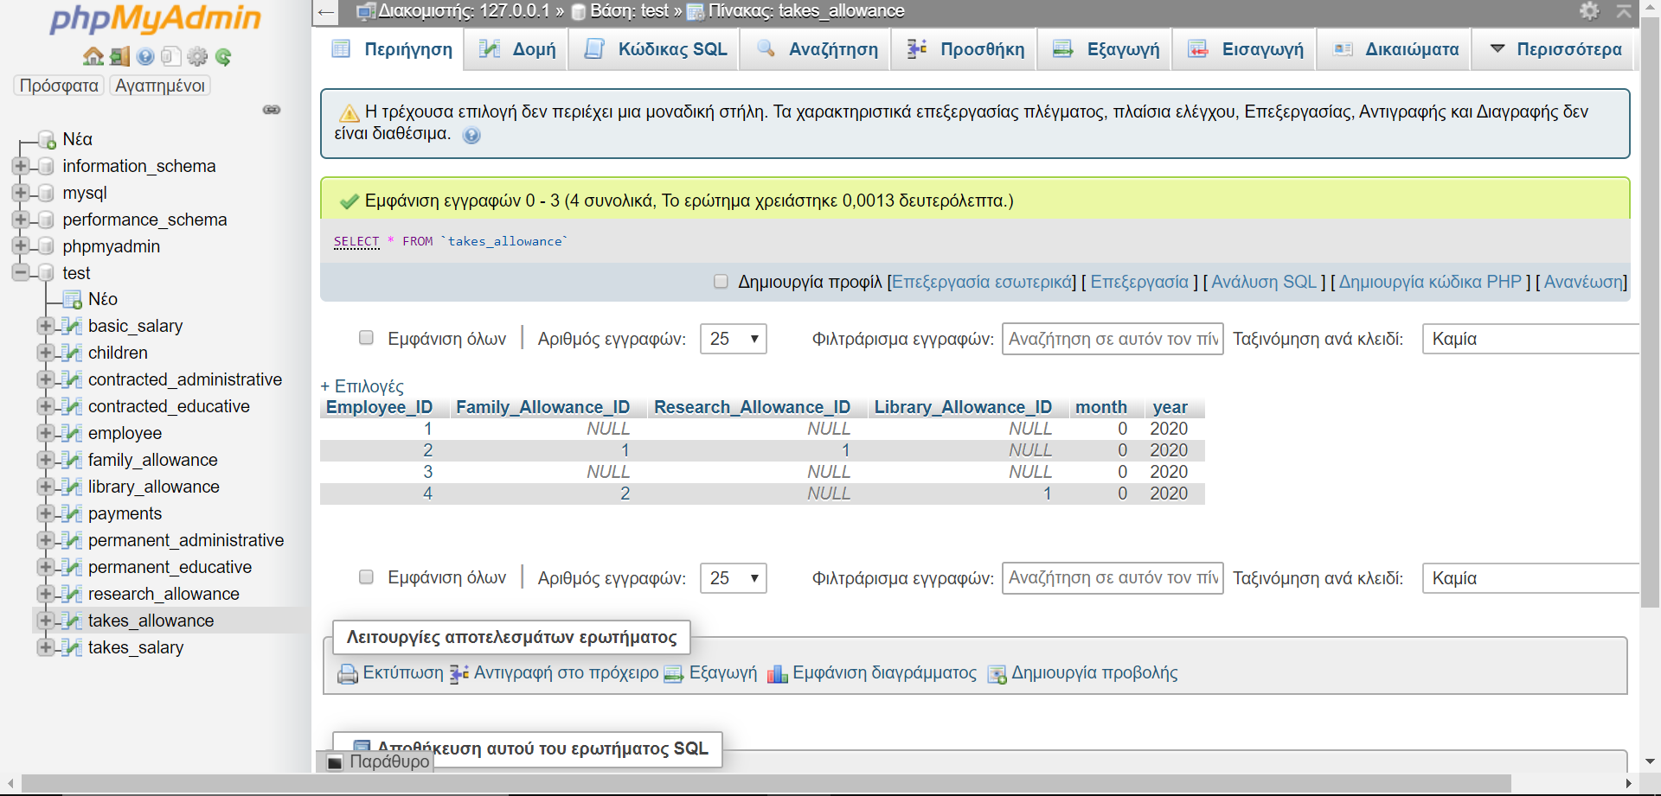

* INSERT INTO employee

(first_name,last_name,bank_name,iban,birthday,address,department,phone_number,start_month,start_year,married,working) VALUES('Antonis','Agapakis','Ethniki','1619447755','05/04/1999','Nikolaidi 4','CSD',645640663,0,0,1,1);



* INSERT INTO permanent_educative VALUES(2);

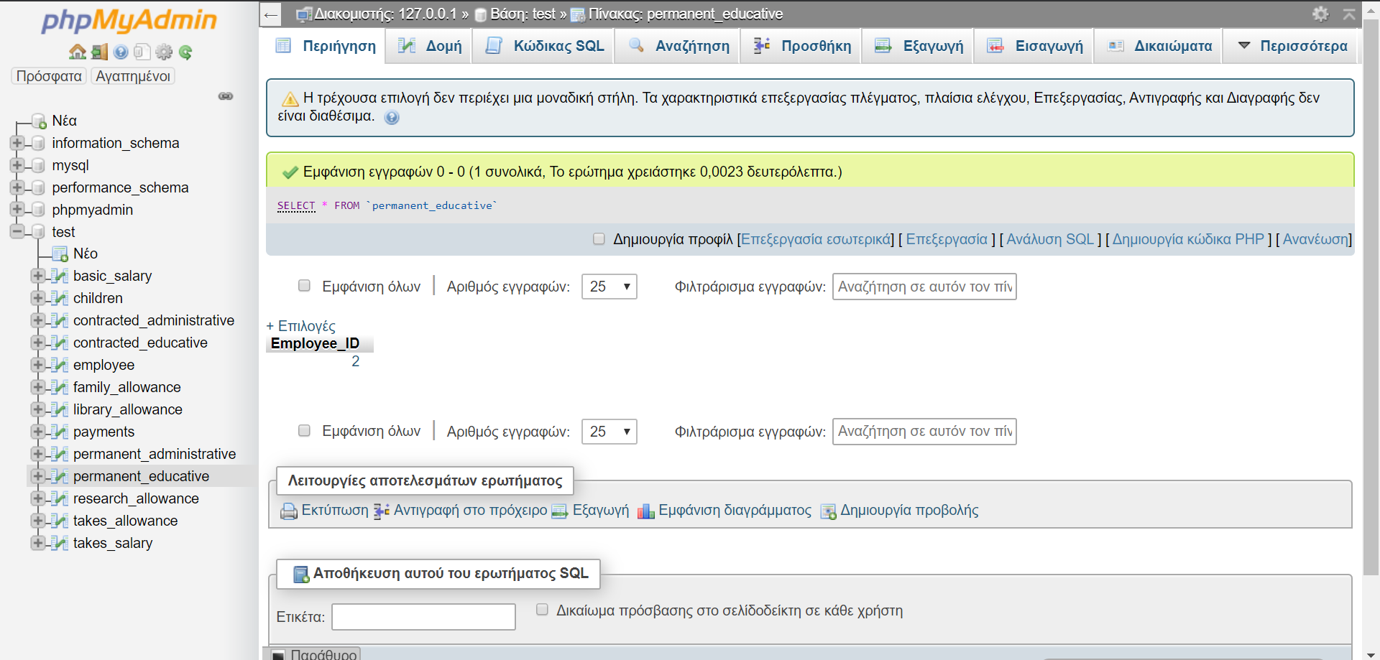

* INSERT INTO children VALUES(2,1);
* INSERT INTO children VALUES(2,2);
* INSERT INTO children VALUES(2,3);

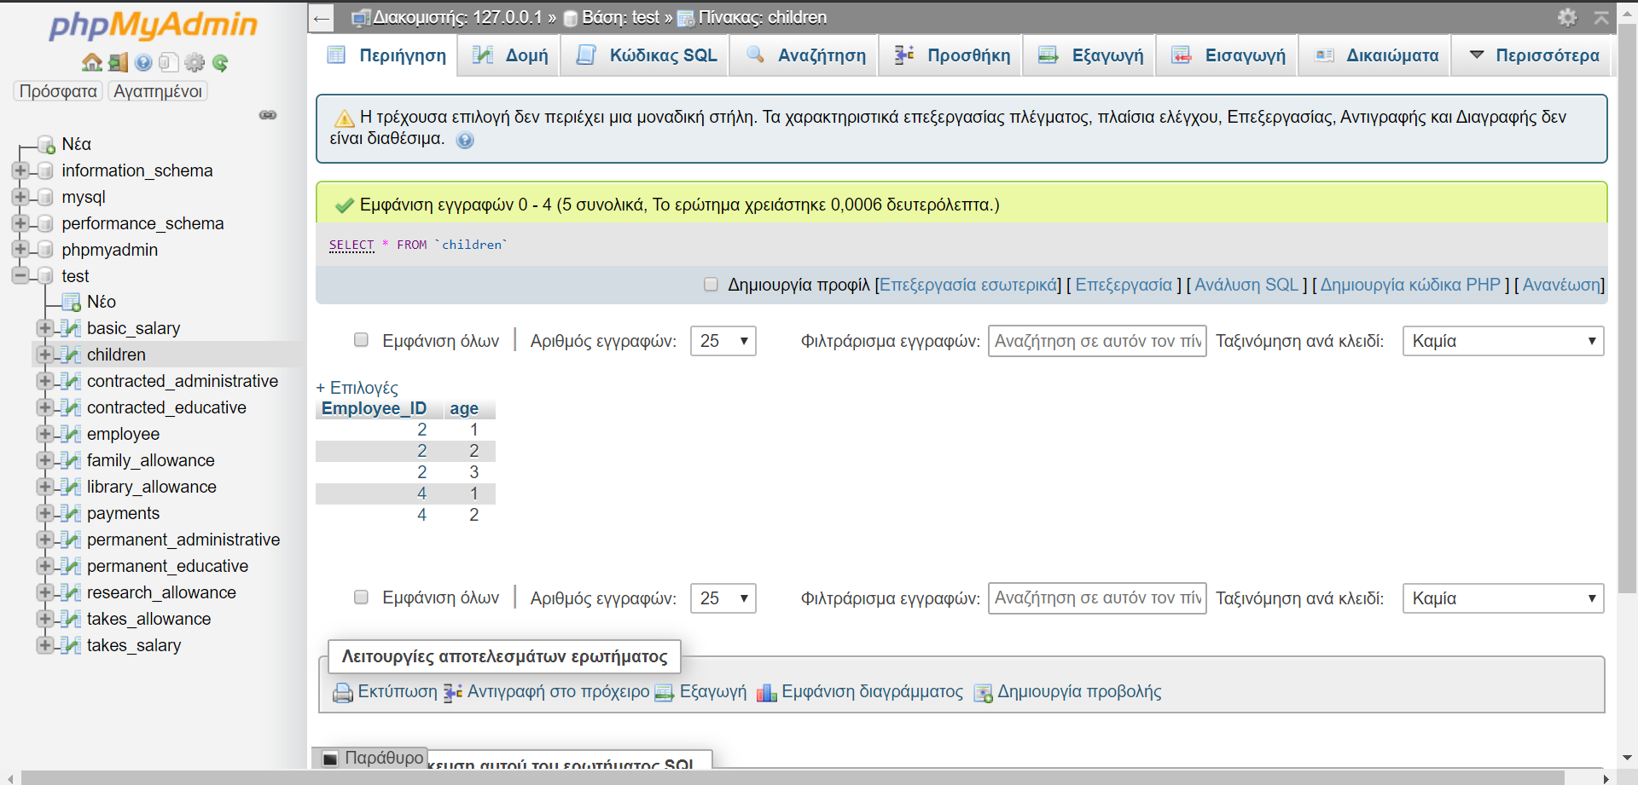

* INSERT INTO family_allowance(percent) VALUES(20);

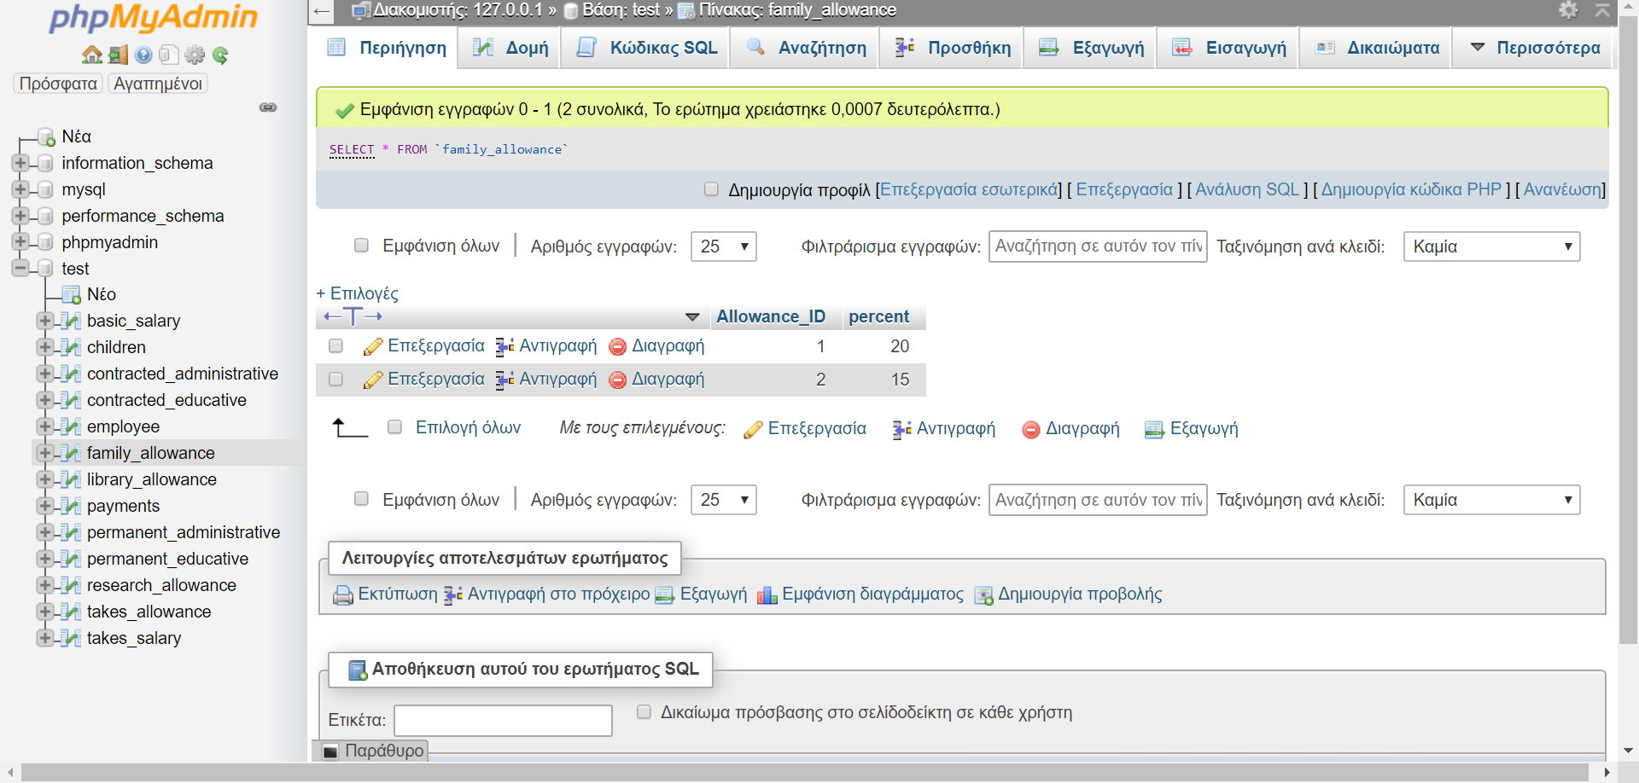

* INSERT INTO Takes_Salary VALUES(2,2,0,2020);



* INSERT INTO Takes_Allowance VALUES(2,1,1,NULL,0,2020);



* INSERT INTO employee

(first_name,last_name,bank_name,iban,birthday,address,department,phone_number,start_month,start_year,married,working) VALUES('Stelios','Stamatakis','Ethniki','1691447676','03/01/1999','Kondilaki 8','CSD','6945710663',0,0,0,1);



* INSERT INTO contracted_administrative VALUES(3,12,2021);

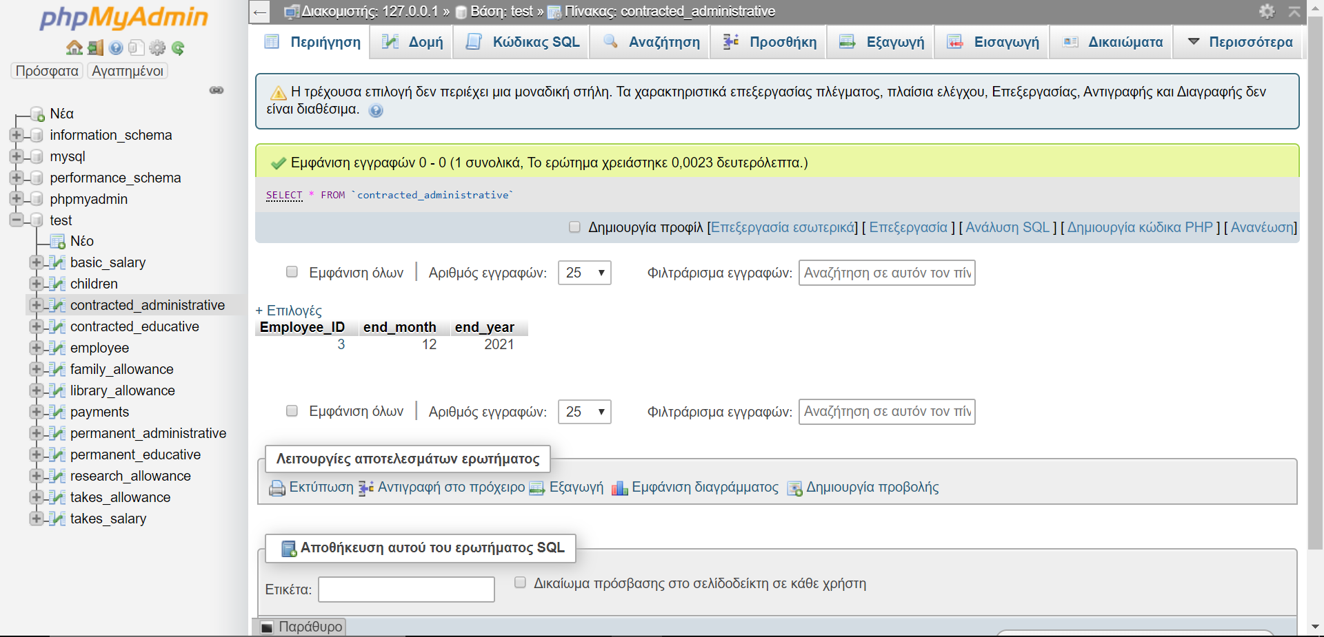

* INSERT INTO Basic_Salary (amount) VALUES(1293);



* INSERT INTO Takes_Salary VALUES(3,3,0,2020);



* INSERT INTO Takes_Allowance VALUES(3,NULL,NULL,NULL,0,2020);



* INSERT INTO employee

(first_name,last_name,bank_name,iban,birthday,address,department,phone_number,start_month,start_year,married,working) VALUES('Zack','Per','Eurobank','1619447646','03/05/1995','nea poli 8','CSD','6912553645',0,0,1,1);



* INSERT INTO contracted_educative VALUES(4,4,2023);

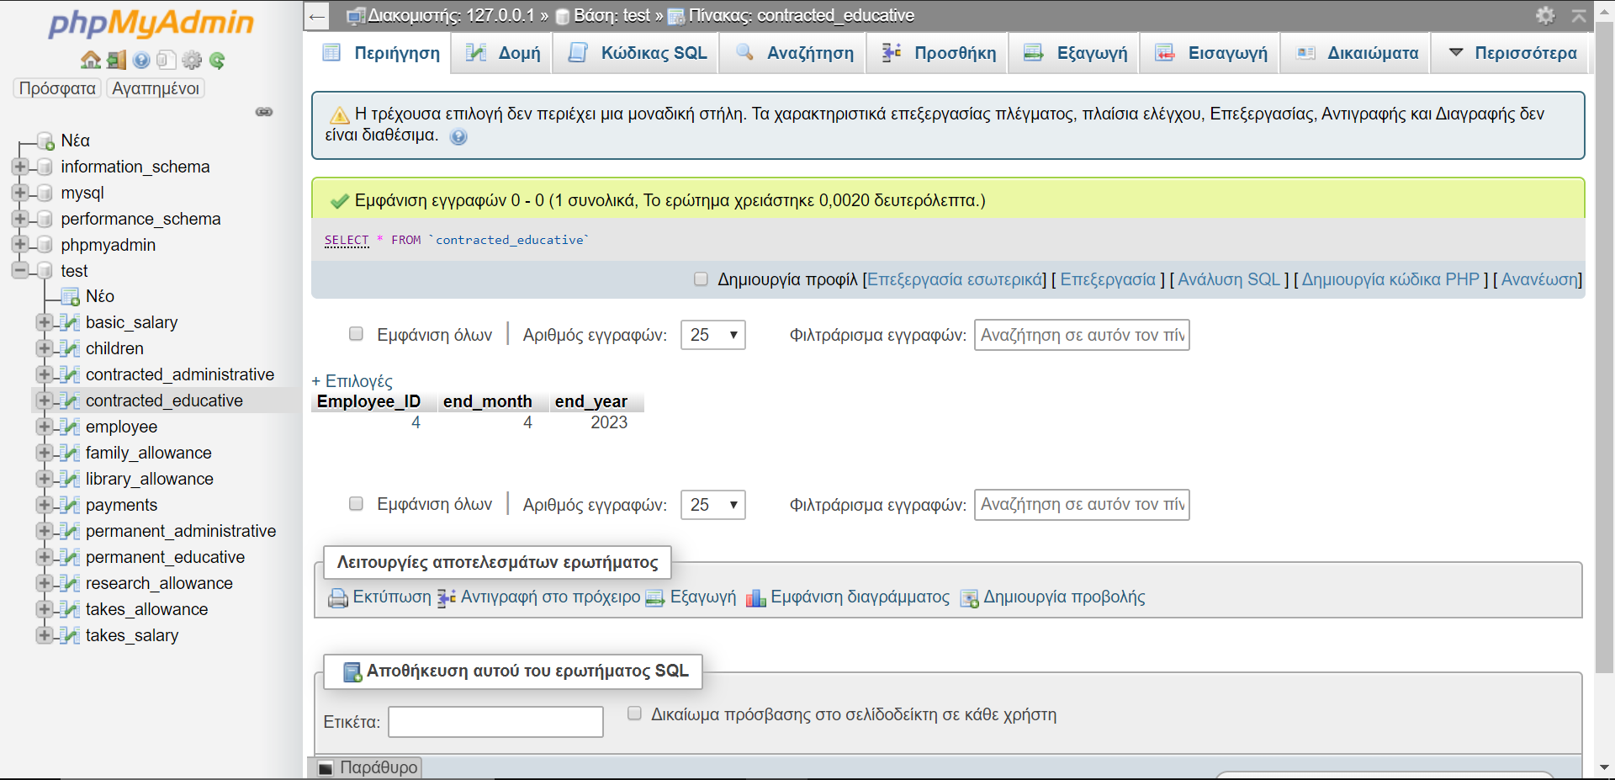

* INSERT INTO Basic_Salary (amount) VALUES(1743);



* INSERT INTO children VALUES(4,1);
* INSERT INTO children VALUES(4,2);



* INSERT INTO family_allowance(percent) VALUES(15);



* INSERT INTO Takes_Salary VALUES(4,4,0,2020);



* INSERT INTO Takes_Allowance VALUES(4,2,NULL,1,0,2020);



1. **Πρόσληψη υπαλλήλου με κουμπί**

* INSERT INTO employee

(first_name,last_name,bank_name,iban,birthday,address,department,phone_number,start_month,start_year,married,working) VALUES('test','testtest','eth','123485eth','03/2003','nea poli','csd',6948673837,0,2020,1,1);

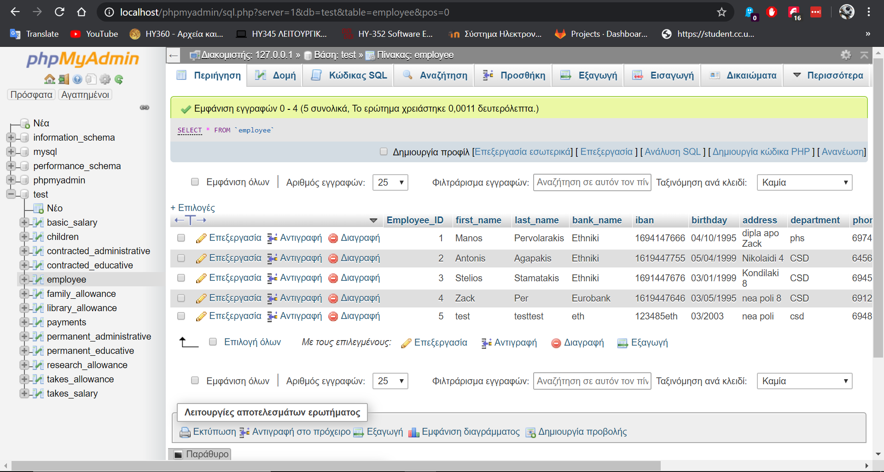

* INSERT INTO permanent_administrative VALUES(5);

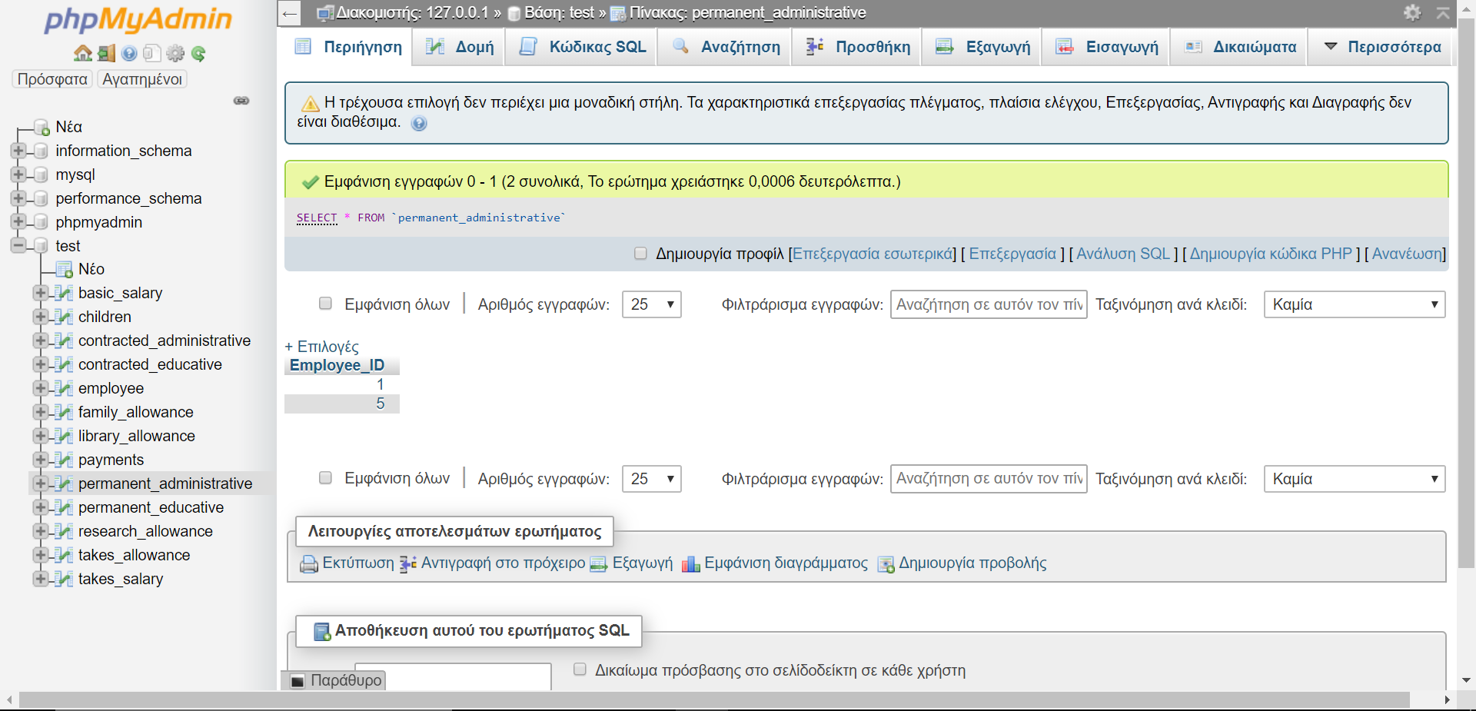

* INSERT INTO family_allowance(percent) VALUES(5);

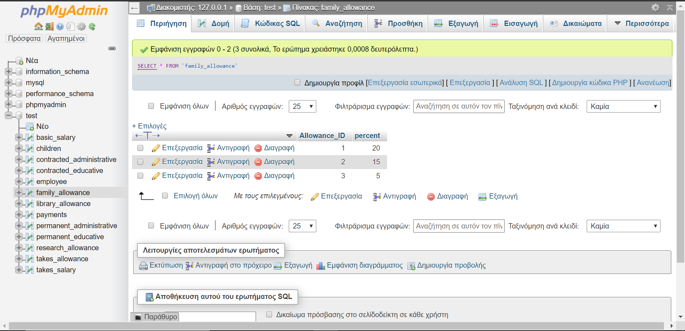

* INSERT INTO Takes_Salary VALUES(5,1,0,2020);

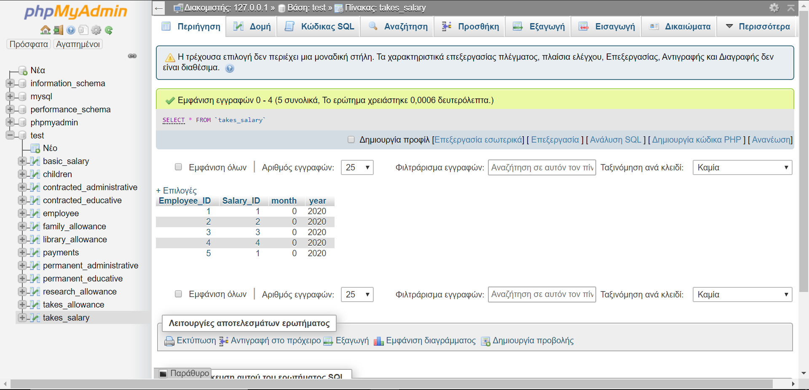

* INSERT INTO Takes_Allowance VALUES(5,3,NULL,NULL,0,2020);

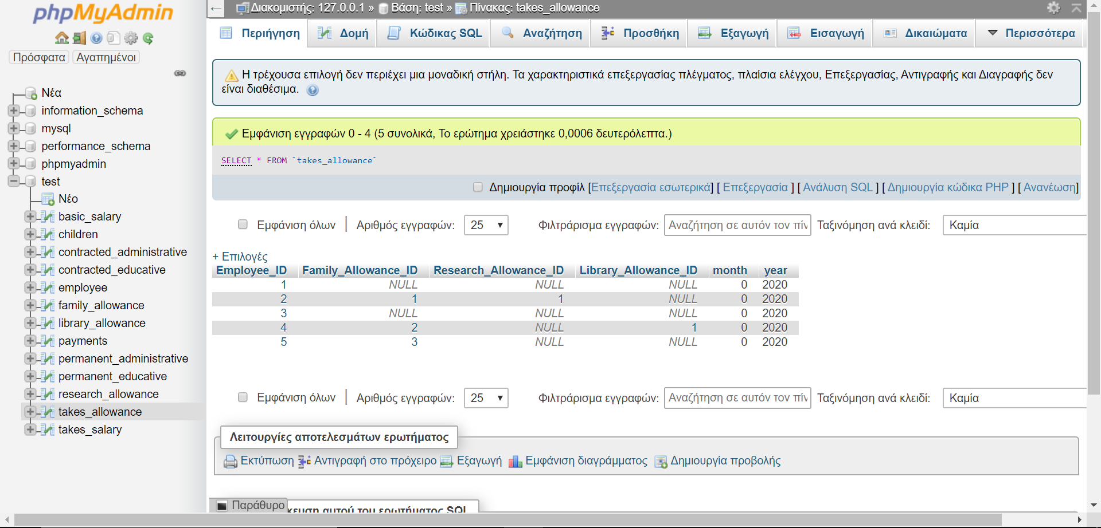

**Screenshots**

* προσληψη

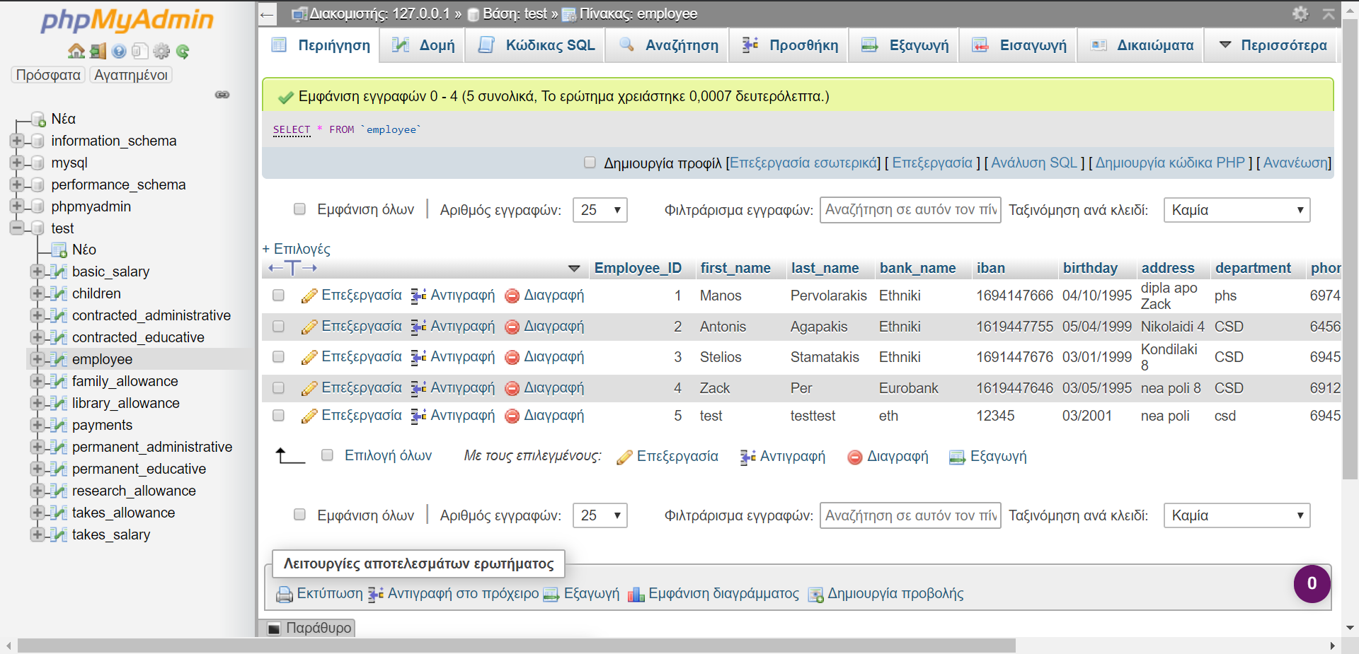

* συναψη νεας συμβασης

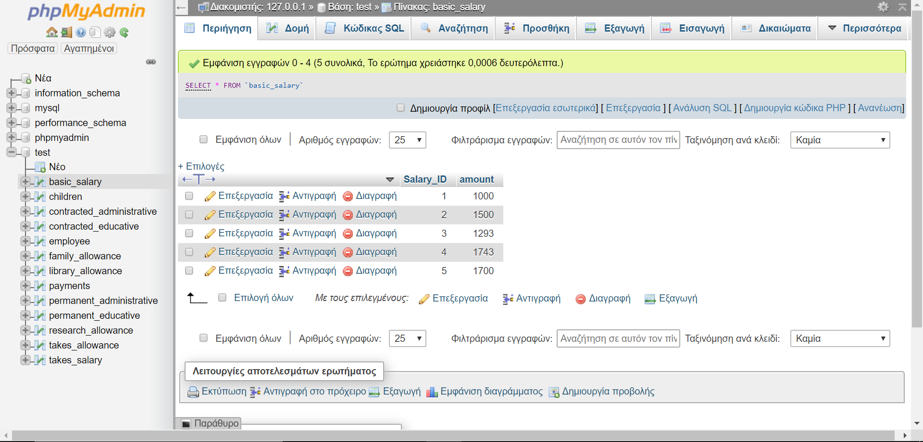

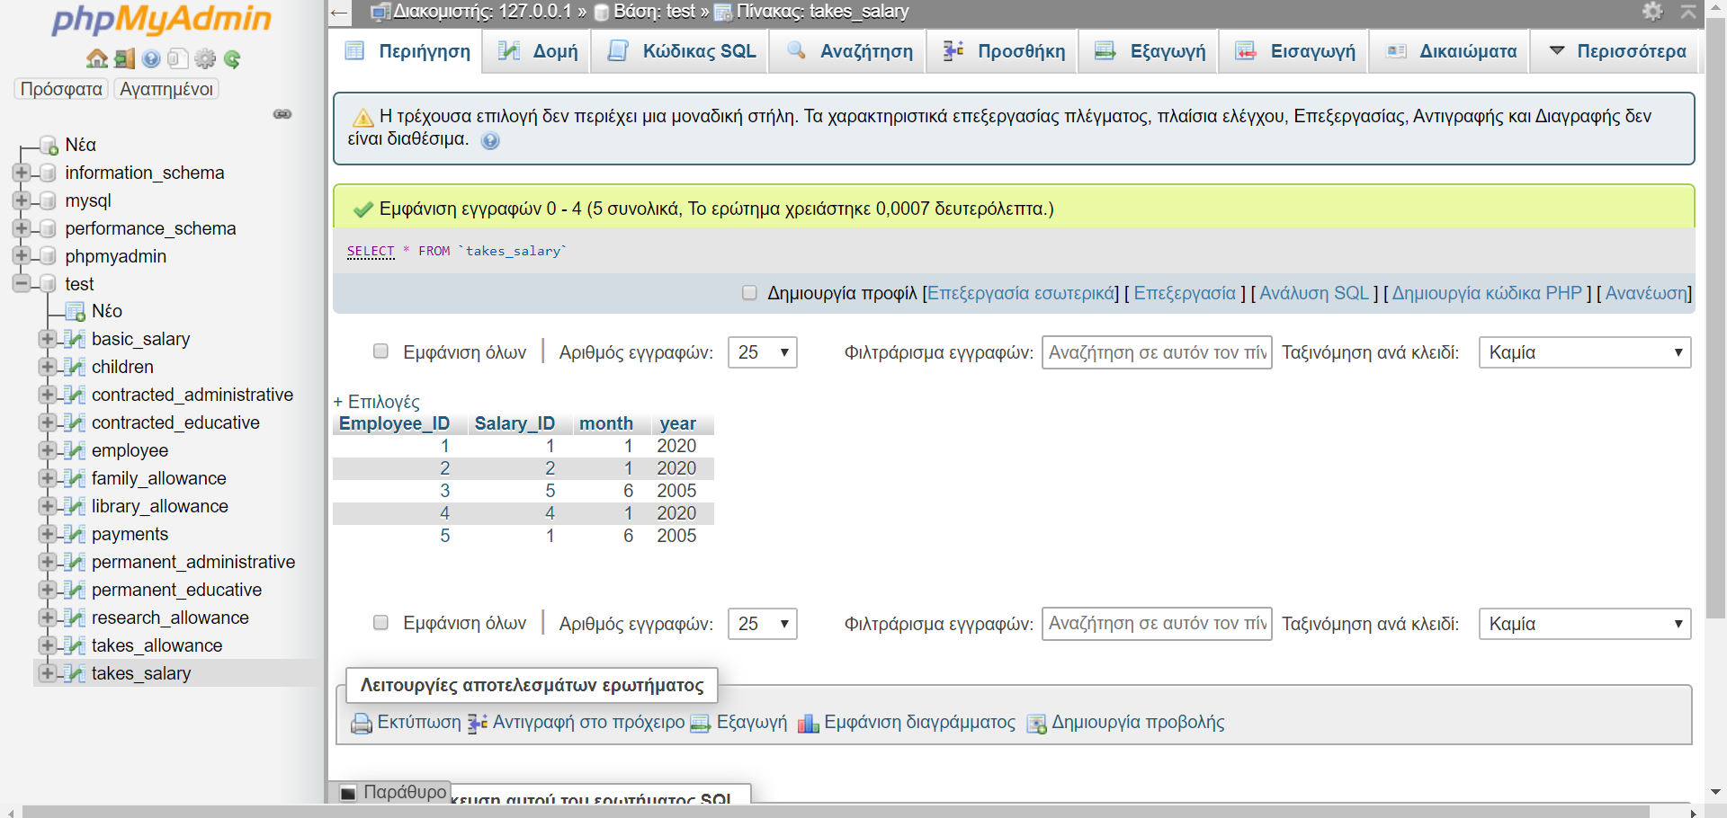

* Αλλαγη στοιχιων δεδομενων

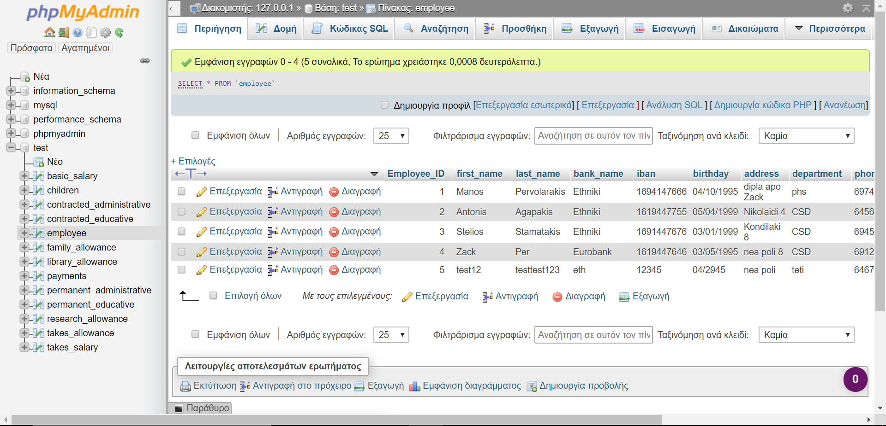

* Αλλαγη βασικων μισθων και επιδοματων

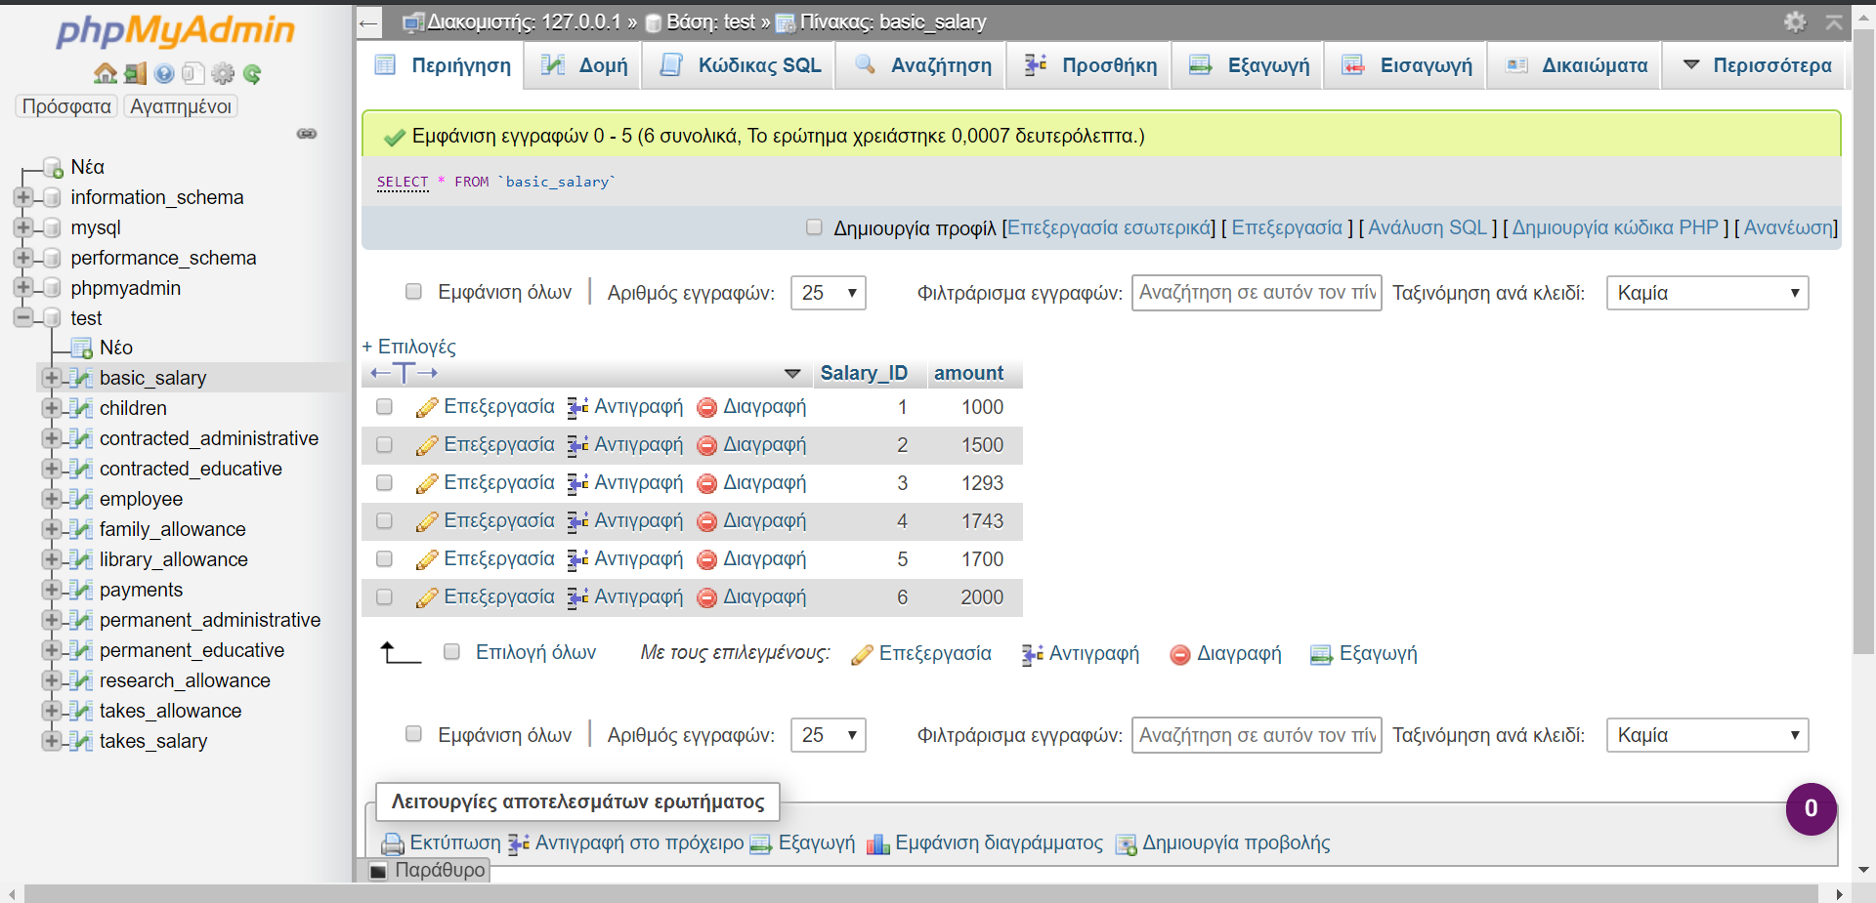

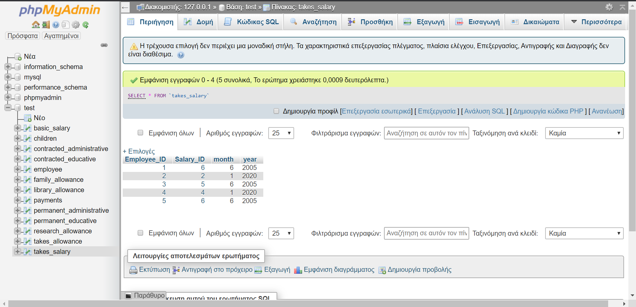

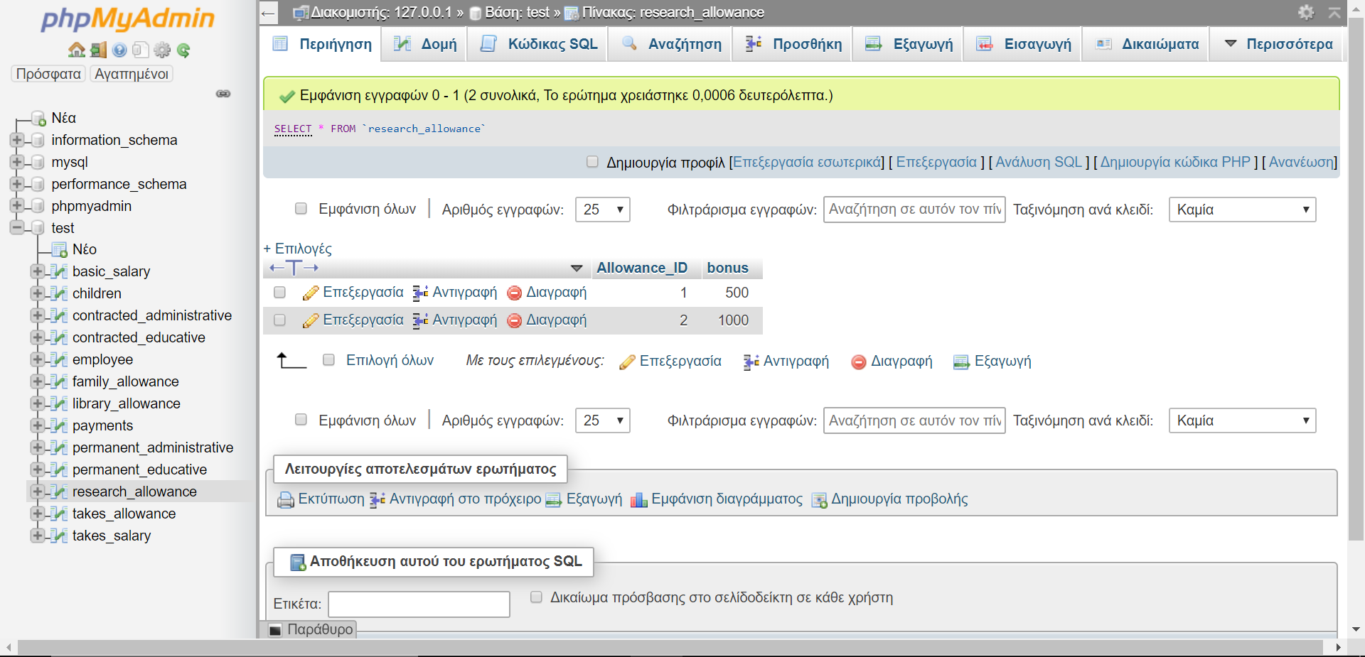

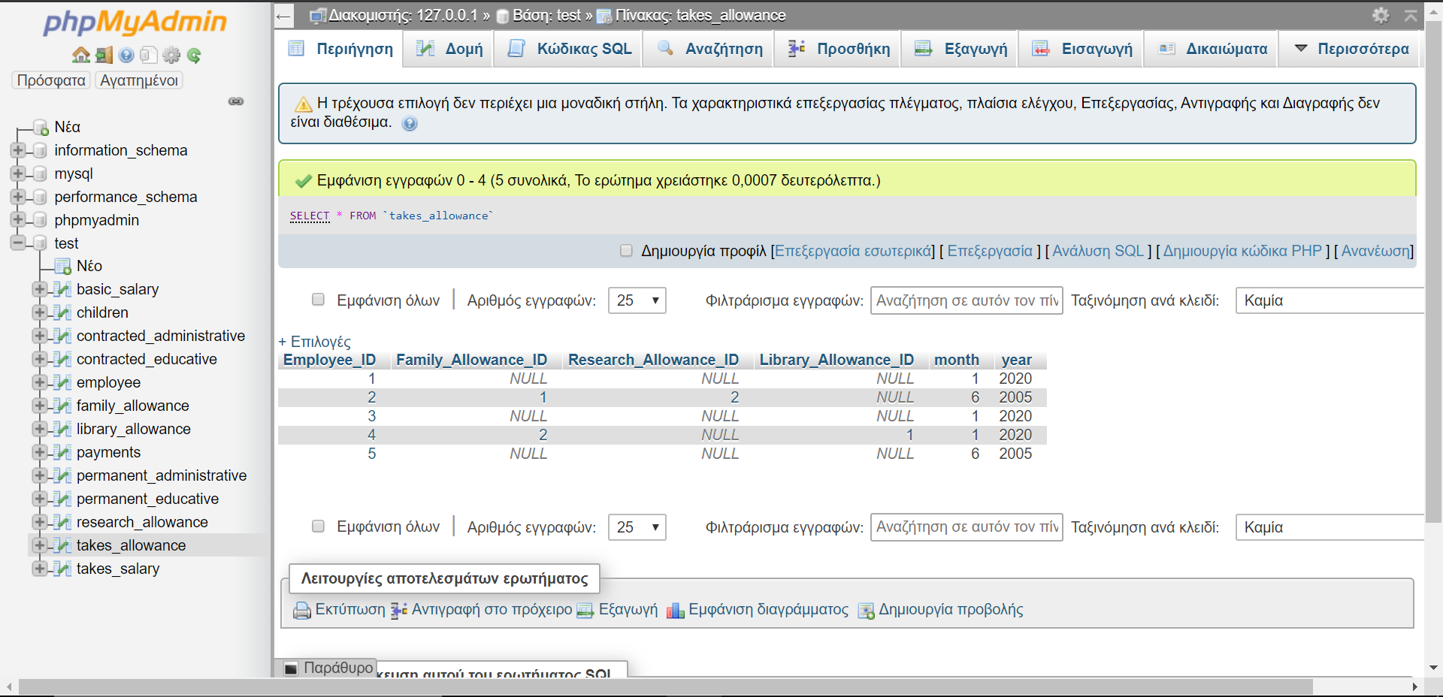

* Απολυση & συνταξιοδοτηση

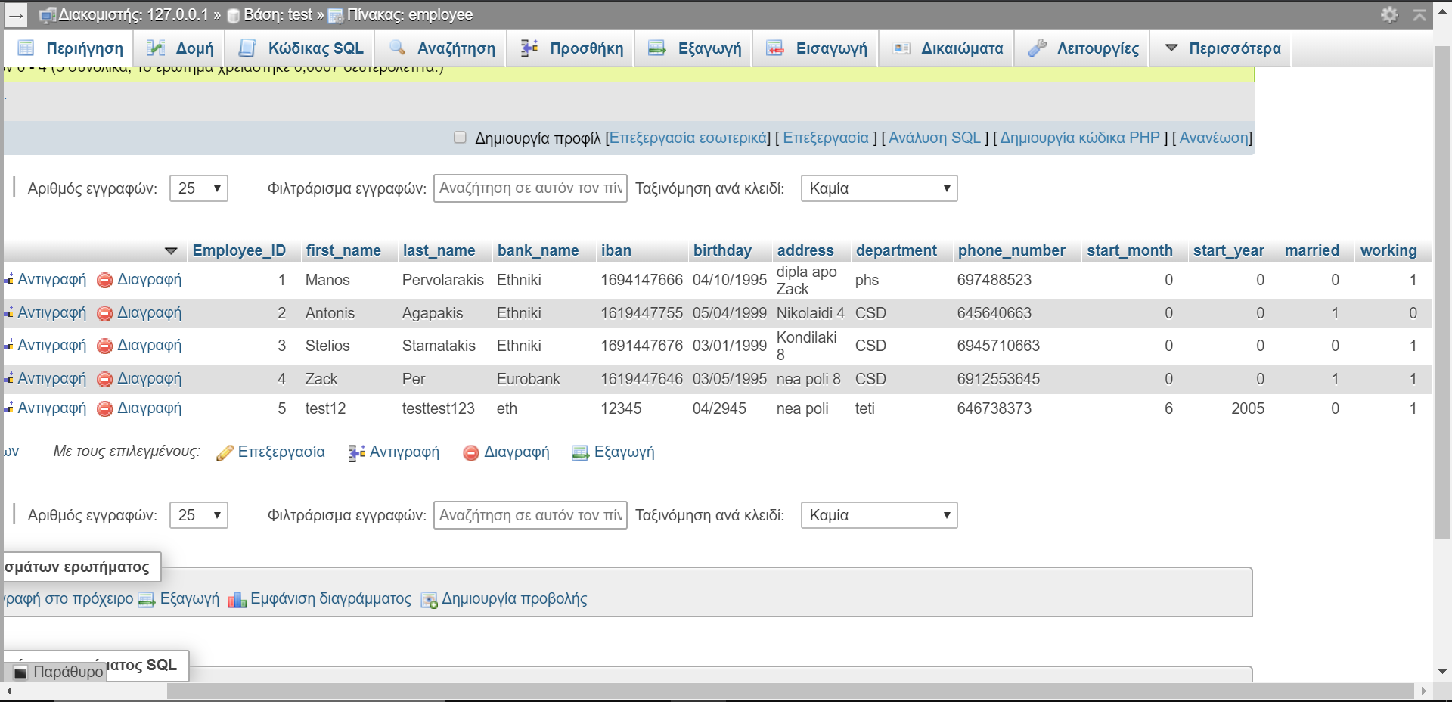

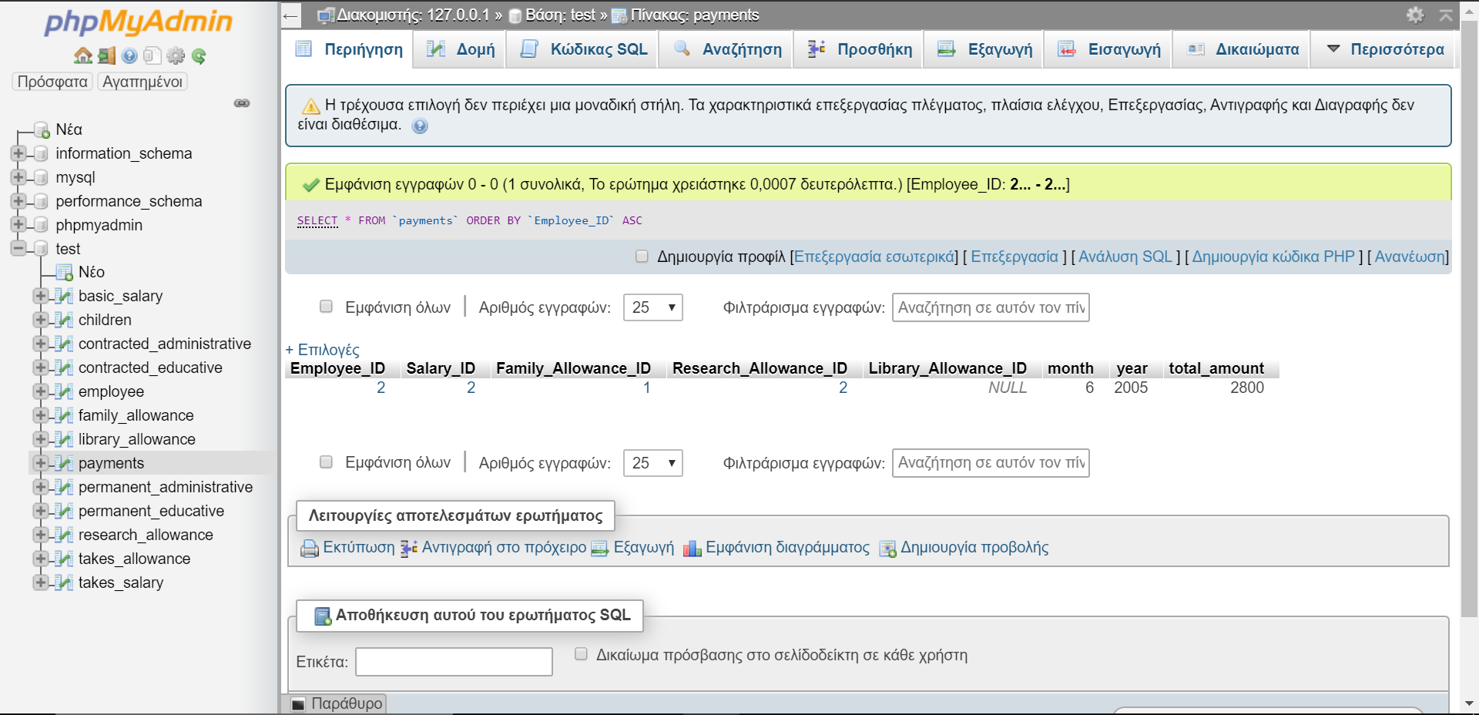

* Προαγωγη συμβασιουχου

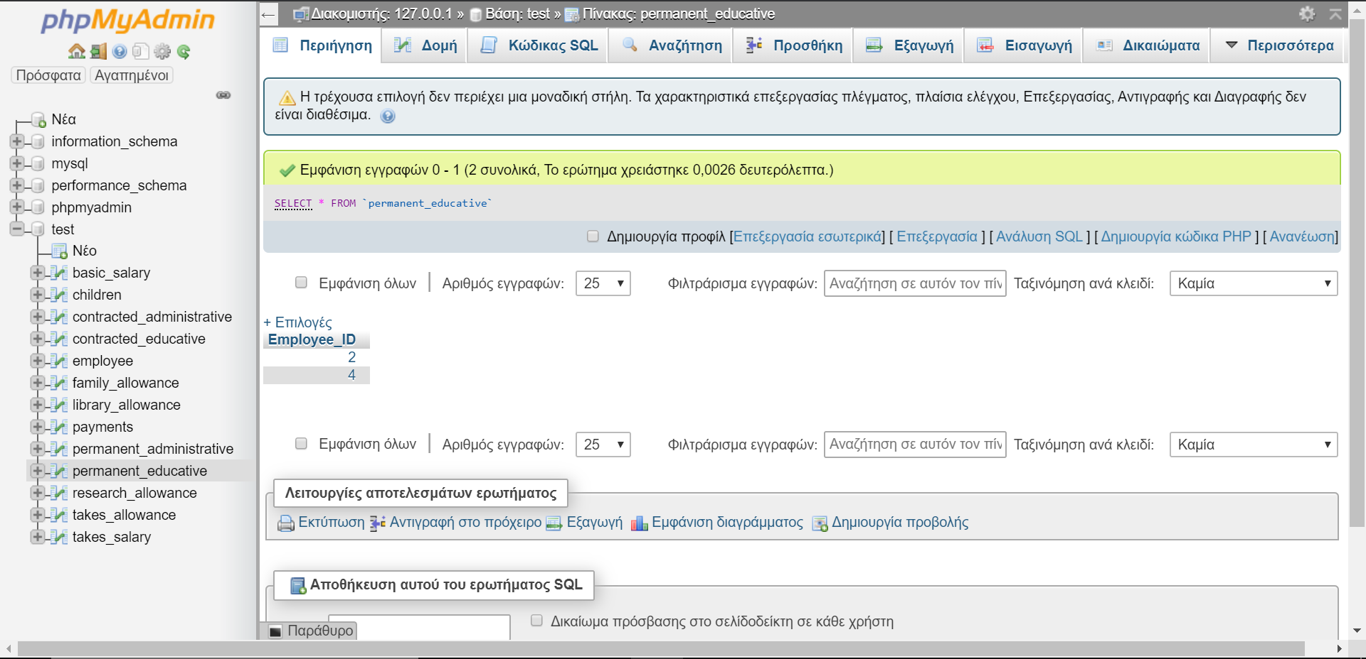

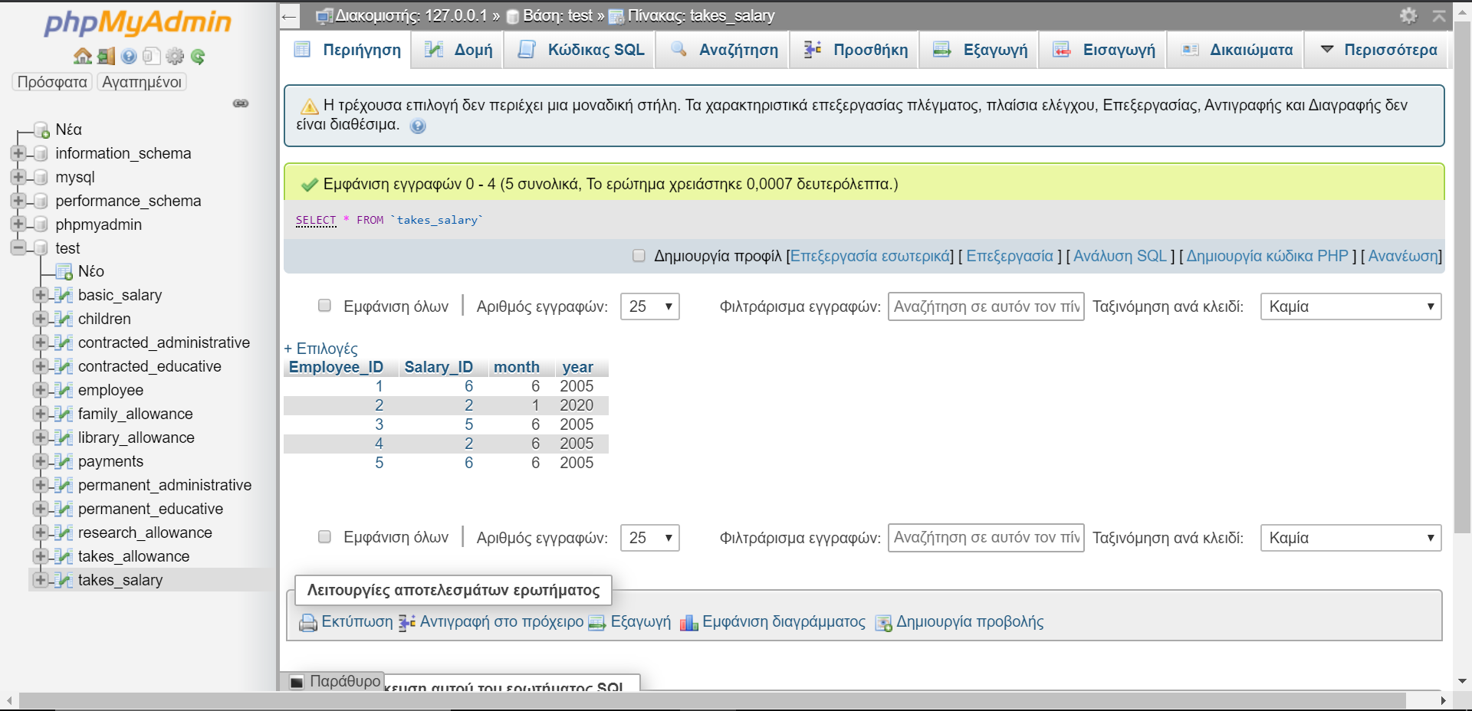

* Πληρωμη εργαζομενων

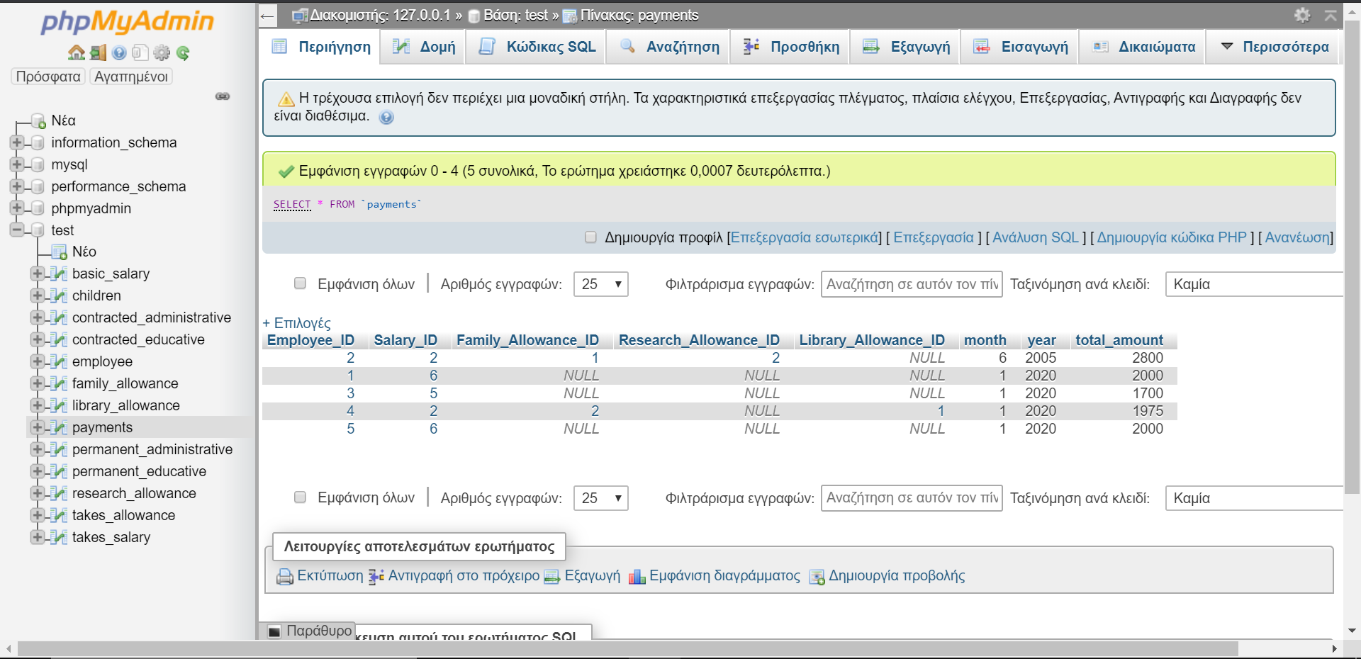

* Κατασταση μισθοδοσιας

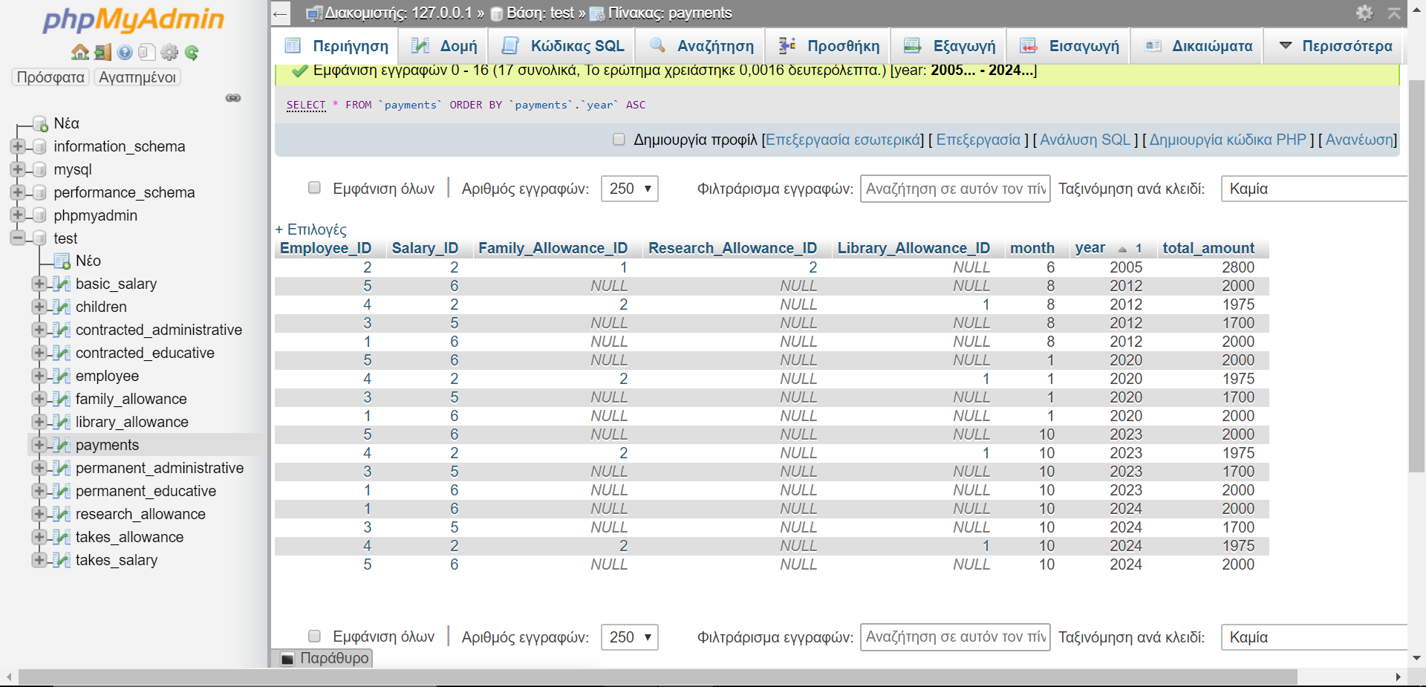

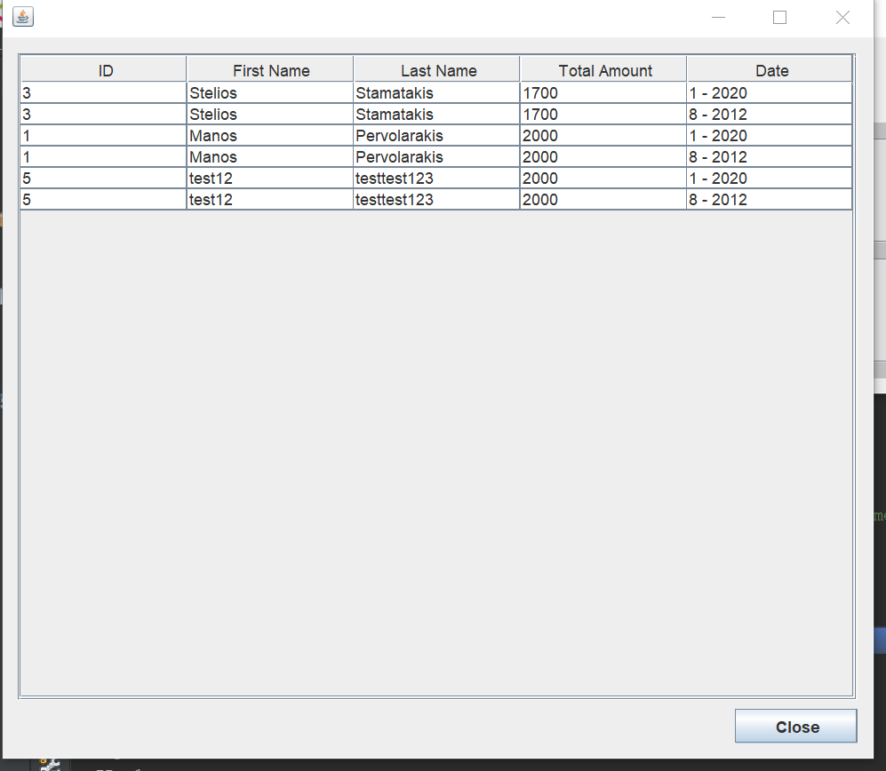

* Μεγιστος ελαχιστος και μεσος μισθος

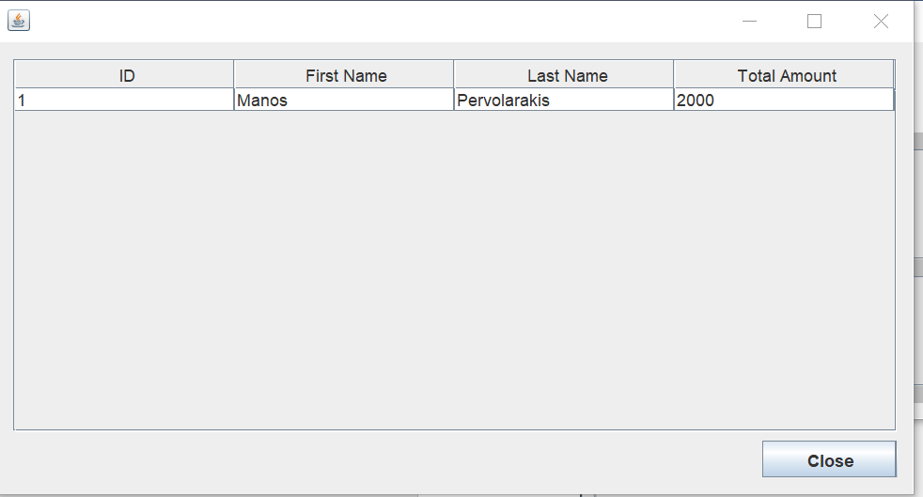

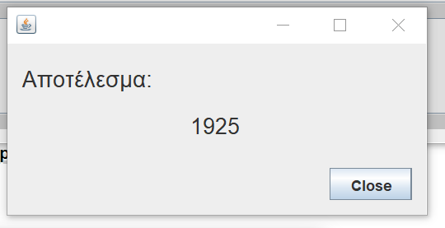

* Μεση αυξηση ανα κατηγορια

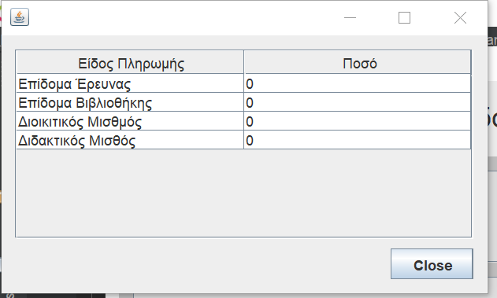

* Στοιχια μισθοδοσιας υπαληλου

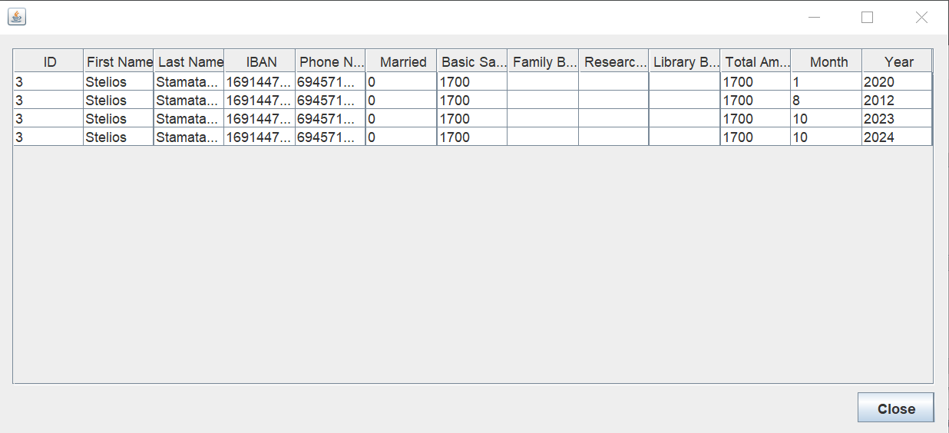

* Συνολικο υψος μισθοδοσια ανα κατηγορια

